A
PROJECT REPORT
ON
Object Detector
SUBMITTED IN THE PARTIAL FULFILLMENT OF THE REQUIREMENT FOR OF

MASTER OF COMPUTER APPLICATION
SUBMITTED BY

Rohit Kadam | SYMCA B 119
Animesh Jain | SYMCA B 120

UNDER THE GUIDANCE OF
Asst. Prof. Rasika Salunkhe


G. H. RAISONI COLLEGE OF ENGINEERING AND
MANAGEMENT

(An Autonomous Institute affiliated to SPPU)
WAGHOLI, PUNE –
412207
SAVITRIBAI PHULE PUNE UNIVERSITY
2025 - 2026

CERTIFICATE
This is to certify that the project report entitled
[ Object Detector]

SUBMITTED BY

Rohit Kadam | SYMCA B 119
Animesh Jain | SYMCA B 120

Are bonafide students of this institute and the work has been carried out by them under the supervision of Asst. Prof. Rasika Salunkhe and it is approved for the partial fulfillment of the requirement of Savitribai Phule Pune University, for the award of the degree of Master of Computer Application.

Asst. Prof. Rasika Salunkhe Dr. priya
Internal Guide External HoD - MCA

Dr. R. D. Kharadkar
Director

Place: Pune
Date:

Acknowledgement.

We are profoundly grateful to Asst Prof. Rasika Salunkhe for his expert guidance and continuous encouragement throughout to see that this project rights its target since its commencement to its completion.

We would like to express our deepest appreciation towards Dr. R. D. Karadkar, Director, G. H. Raisoni College of Engineering and Management, Pune, Dr.Priya Chaudhari, Head of Department, Master of Computer Application and Ms. Rasika Salunkhe Project Coordinator whose invaluable guidance supported us in completing this project.

At last, we must express our sincere heartfelt gratitude to all the staff members of the Computer Engineering Department who helped us directly or indirectly during this course of work.

ROHIT KADAM _________________
ANIMESH JAIN _________________

Table of Content

CONTENTS | Page No.
I.Chapter-1
Introduction of the My AI Assistant | 1
1.1. Abstract of the Project……………………………………………… | 1
1.2 Scope of the Project………………………………………………… | 2
1.3 Reports of the My AI Assistant ………………………………………….. | 2
1.4 Modules of the My AI Assistant ………………………………………… | 3
1.5 Objective…………………….……………………………………… | 4
II.Chapter-2
Requirement Engineering | 5
2.1 Functional Requirements………………………………. | 5
2.2 Non- Functional Requirements ………………………………..……… | 5
2.3 Hardware and Software Requirements………………………………. | 5
2.4 Assumptions ……………………………….………………………………. | 5
III.Chapter-3
Analysis & Design
3.1 System Analysis and Design …………………………………….. | 6
3.2 Primary Design Phase …………………………………………… | 6
3.3 Secondary Design Phase ………………………………….…………………. | 7
3.4 Project Planning…………………………………………………… | 7
3.5 Steps for successful software project………………………………. | 8
3.6 Project Scheduling………………………………………………… | 9
3.7 Project Profile………………………………………..……………. | 9
3.8 What is UML…………………………………… | 10
3.9 Use Case Model of the project………………………………………..… | 11
3.10 Dataflow Diagram………………………………………………………… | 12-15
IV.Chapter-4
Construction
4.1 Implementation and Software Specification Testing……………… | 16
4.2 The Steps in Software Testing | 17
4.2.1 Unit Testing Steps | 17
4.2.2 Unit Testing Covered ……………………………… | 17
4.2.3 System Integration Testing ……………………………… | 17
4.2.4 Proposed My AI Assistant……………………… | 18
V.Chapter-5
Conclusion & Future Works
5.1 Conclusion of the Project My AI Assistant……………………… | 19
5.2 Future Scope of the Project ………………………………..………..... | 19
VII.Chapter-6
Codes & Snapshots
6.1 Codes………………………………………………………… | 20-25
6.2 Snapshots of the project………………………………..…………. | 26-31
6.3 References and Bibliography………………………..…………. | 32
6.4 Notes……………………………..…………. | 33

I. Chapter-1
Introduction
The Object Detector project is a computer vision-based application designed to automatically identify and classify objects within images or video streams. Instead of manually labeling or detecting items, this tool leverages deep learning models to recognize relevant objects such as people, vehicles, animals, or everyday items in real time. The system organizes the detected objects with bounding boxes, labels, and confidence scores, making the results easy to interpret. This project utilizes Python, OpenCV, TensorFlow/Keras, and other libraries for image processing, model training, and inference. It aims to simplify the task of visual recognition, supporting use cases in surveillance, automation, traffic monitoring, and assistive technologies. The motivation behind this project is the increasing demand for intelligent systems that can understand and interact with visual environments. By automating object detection, the application ensures efficiency, accuracy, and wide applicability across various domains.

1.1 Abstract of the Object Detector:
The Object Detector is a computer vision-based application that automatically identifies and classifies objects within images or live video streams. It leverages deep learning models implemented using Python, TensorFlow/Keras, and OpenCV to provide accurate, real-time detection. The system processes visual data, assigns bounding boxes, labels, and confidence scores to each detected object, and organizes the results in a structured and interpretable format. By automating object recognition, the project reduces manual effort, improves accuracy, and enables consistent detection across large datasets. It supports multiple use cases such as surveillance and security, traffic analysis, autonomous vehicles, industrial automation, retail monitoring, and assistive technologies. The application demonstrates the practical integration of machine learning and computer vision, highlighting how AI can interact with real-world environments to simplify complex tasks, enhance efficiency, and open doors for innovative solutions.
.
1.2 Scope of the project Object Detector:
The Object Detector project focuses on automating the task of identifying and classifying objects within images and video streams using computer vision and deep learning techniques. It simplifies visual recognition by detecting objects such as people, vehicles, and everyday items, and presenting them with bounding boxes, labels, and confidence scores. The system utilizes Python with TensorFlow/Keras and OpenCV for model training, inference, and image processing, ensuring accuracy and real-time performance.This project benefits fields such as surveillance, autonomous vehicles, traffic monitoring, industrial automation, and assistive technologies by reducing manual effort, improving efficiency, and providing consistent object recognition. The application can be extended with features like multi-object tracking, integration with IoT devices, and cloud-based deployment for large-scale monitoring. With its scalability and adaptability, the Object Detector provides a practical solution to modern challenges where intelligent visual recognition is essential in today’s fast-paced and technology-driven environment.
1.3 Reports Object Detector:
- Developed a computer vision application to automate the detection and tracking of objects in images and video streams.
- Selected Python as the core language with OpenCV and TensorFlow/Keras for model implementation and image processing.
- Integrated deep learning models for real-time object detection and classification with bounding boxes, labels, and confidence scores.
- Implemented preprocessing and data handling techniques to improve detection accuracy and consistency across diverse datasets.
- Designed visualization modules to present detection results clearly for monitoring and analysis.
- Added functionality for real-time video processing, enabling continuous tracking of objects across frames.
- Ensured a user-friendly interface for easy input of images or video streams and viewing results.
- Focused on target use cases including surveillance, traffic monitoring, autonomous systems, industrial automation, and assistive technologies.
- Considered scalability for future improvements such as multi-object tracking, cloud deployment, integration with IoT devices, and alert systems for specific detections.
1.4 Modules Object Detector:
- Main Interface
• The user interacts directly with the application interface without needing registration.
• The interface is simple and intuitive, designed for quick input of images or video streams.
- Data Input Module
• Accepts images, video files, or live camera feeds for object detection.
• Ensures compatibility with multiple formats and resolutions for flexible use.
- Object Detection Module
• Uses deep learning models (TensorFlow/Keras) to identify objects in images or video frames.
• Assigns bounding boxes, labels, and confidence scores for accurate recognition.
- Object Tracking Module
• Tracks objects across frames in real time using unique IDs for continuity.
• Handles occlusions and maintains detection consistency for moving objects.
- Output and Visualization Module
• Displays detected objects with annotated bounding boxes and labels for easy interpretation.
• Provides options to save processed images or videos for reporting and analysis.

1.5 Objective:
- To develop a tool that automatically detects and tracks objects in images and video streams.
- To minimize manual effort in identifying and monitoring objects.
- To provide accurate and real-time object recognition with bounding boxes, labels, and confidence scores.
- To ensure consistency and reliability in detection across different datasets and scenarios.
- To offer a simple, user-friendly interface for uploading and processing visual data.
- To save time and improve efficiency for applications such as surveillance, traffic monitoring, and industrial automation.
- To design a scalable system that can be extended with features like multi-object tracking, cloud deployment, and IoT integration.

II. Chapter-2
2.1) Requirement Engineering
2.1.1. Functional Requirements:
• Data Input Handling: Allows users to upload images, video files, or connect to live camera feeds.
• Object Detection: Automatically identifies objects in images or video using deep learning models.
• Object Tracking: Tracks detected objects across frames in real-time, maintaining unique IDs.
• Annotation and Visualization: Displays bounding boxes, labels, and confidence scores for each detected object.
• Output Export: Enables saving processed images or videos with annotations for reporting or analysis.
• Configuration Options: Allows customization such as selecting object categories or adjusting detection thresholds.
2.1.2. Non-Functional Requirements:
• Usability: Simple and intuitive interface for easy interaction with the system.
• Performance: Processes images and video streams efficiently for real-time detection and tracking.
• Scalability: Supports adding new object classes, models, or integration with additional data sources.
• Availability: Works on desktop environments and can be extended for web or mobile platforms.
• Security: Ensures safe handling of uploaded data and prevents unauthorized access.
2.1.3. Hardware and Software Requirements:
• Hardware: Desktop or laptop with a decent GPU for faster model inference (recommended), or CPU for small-scale use.
• Software: Python-based system using libraries such as OpenCV, TensorFlow/Keras, NumPy, and other supporting packages for model training, detection, and visualization.
2.1.4. Assumptions:
• User Environment: Users have access to images, video files, or live camera feeds and a computer capable of running the application.
• Language/Region Support: Initially supports object detection in images/videos globally without language dependency.
• Data Availability: Users provide images or video content for detection, and the system assumes standard visual quality for accurate recognition.

III. Chapter-3
3.1 Analysis & Design
System Design for Object Detector.
3.2 Primary Design Phase:
• High-Level Module Definition:
o Define core blocks such as Data Input, Object Detection, Object Tracking, Output & Visualization, and User Interface.
• Minimized Interaction Between Blocks:
o Keep modules independent, focusing on minimizing interaction:
o Data Input block only handles image/video feed acquisition and preprocessing.
o Object Detection block only performs object recognition and labeling.
o Object Tracking block handles real-time tracking and ID assignment independently.
o Output & Visualization block displays results without altering detection or tracking logic.
o User Interface block manages user interactions without processing or modifying data directly.
3.3 Secondary Design Phase:
• Detailed Block Design:
• Design logic for each block, e.g., Object Detection (using TensorFlow/Keras models) and Object Tracking (using OpenCV tracking algorithms).
• Modular Design:
• Break down each block into smaller sub-modules. For example:
o Object Detection → sub-modules for preprocessing, model inference, and post-processing.
o Object Tracking → sub-modules for ID assignment, frame-to-frame association, and occlusion handling.
• Database/Storage Design:
• Optional storage for saving processed videos, detection logs, or user preferences using local files or lightweight databases.
• Input/Output Design:
• Input: Users provide images, video files, or live camera feed.
• Output: Detected objects displayed with bounding boxes, labels, and confidence scores; option to save annotated images/videos.
• Program Specification:
• Define core algorithms for object detection, tracking, visualization, and optional alerts.
• Documentation:
• Document the design process including flow diagrams, module specifications, and detection pipeline.
• System Reviews:
• Review design with stakeholders (or mentor/professor) to ensure it meets accuracy, performance, and usability requirements.
3.4 Project Planning:
1. Within the Organization:
• Implementation Strategy:
o The project will be developed in phases: requirement analysis, design, development, and testing.
• Constraints:
o Time: Complete development within 3–4 months.
o Cost: Allocate budget for software tools, libraries, and hardware (GPU recommended).
o Staff: Small development team (2–3 developers).
• Market Strategy:
o Focus on applications in surveillance, traffic monitoring, automation, and assistive technologies.
2. With Respect to the Customer:
• Timely Meetings & Status Reports:
o Weekly meetings to present progress, gather feedback, and implement improvements.
• Customer Feedback:
o Incorporate feedback to enhance detection accuracy, tracking consistency, and output visualization.
• Milestones & Deliverables:
o Key Milestones:
♣ Initial design completion and module planning.
♣ Implementation of core features (object detection, tracking, visualization).
♣ Final testing, bug fixing, and deployment of the Object Detector system.
3.5 Steps for a Successful Software Project:
• Select a Project:
• Aims & Objectives: Develop an Object Detector that automatically detects and tracks objects in images and video streams.
• Requirements & Specification:
• Data input handling, object detection and tracking, visualization, and optional export of results.
• Analysis, Design & Implementation:
• Follow iterative development with user feedback to ensure accuracy and usability.
• Testing Techniques:
• Unit testing, integration testing, and real-time testing on images/videos for detection and tracking performance.
• Documentation:
• Document code, design diagrams, detection pipeline, and a user guide for the system.
• Project Milestones & Deliverables:
• Prototype of object detection module.
• Implementation of object tracking and visualization modules.
• Final release of the complete Object Detector system.
• Budget Allocation:
• Allocate funds for tools, libraries (OpenCV, TensorFlow/Keras), and hardware (GPU/CPU).
• Project Estimates:
• Cost: Estimated budget for development tools, libraries, and hardware.
• Time: Estimated completion within 3–4 months.
• Size of Code: Approximately 2000–3000 lines of Python code.
• Duration: Total project duration of 3–4 months.
• Resource Allocation:
• Hardware: Desktop/laptop with GPU recommended, or CPU for small-scale use.
• Software: Python, OpenCV, TensorFlow/Keras, NumPy, and supporting libraries.
• Previous Relevant Projects: Reference prior computer vision or object detection projects for guidance.
• Digital Library: Access to online documentation and tutorials for libraries and AI models used.
• Risk Management:
• Risk Avoidance: Plan for potential obstacles like poor-quality videos/images or model inference delays.
• Risk Mitigation: Implement error handling, fallback options, and model optimization for different hardware.
.

3.6 Project Scheduling:

An elementary Gantt chart or Timeline chart for the development plan is given below. The plan explains the tasks versus the time (in weeks) they will take to complete
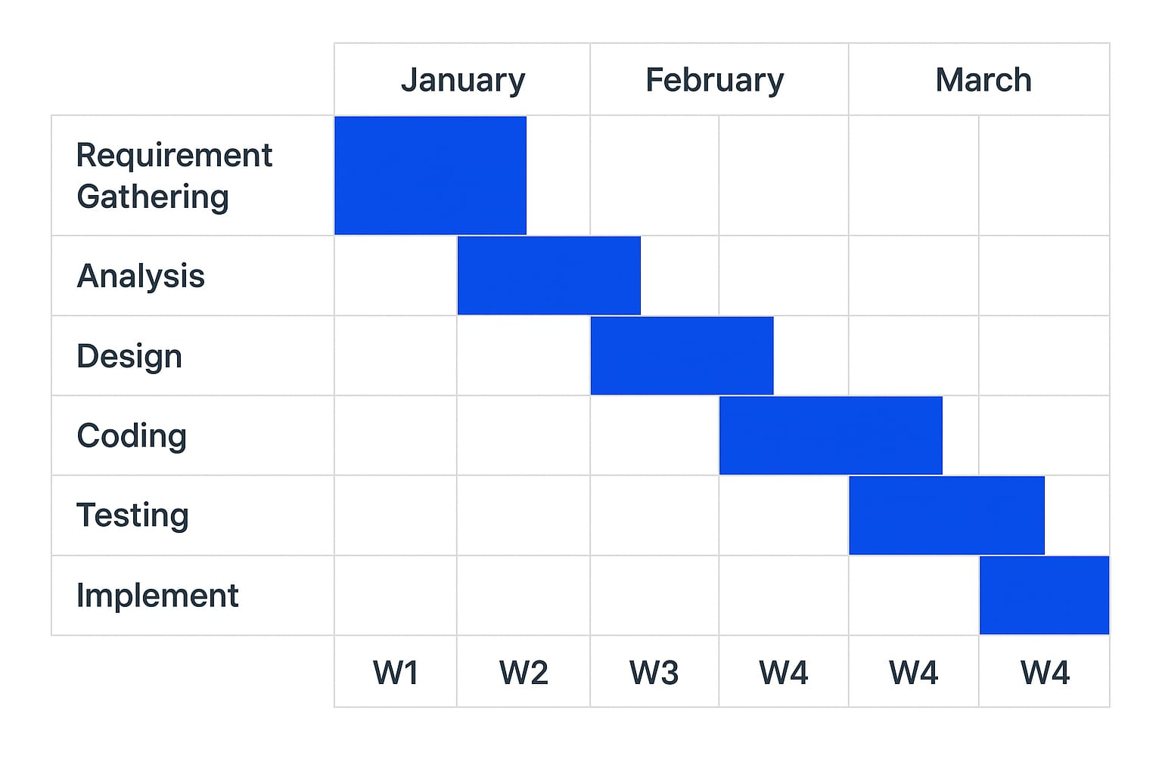

3.7 Project Profile
The Object Detector is a tool designed to simplify and automate the process of identifying and tracking objects in images and video streams. It aims to provide an intuitive and efficient user experience by detecting objects in real time and presenting results with clear annotations.
Key features include:
• Object Detection: Automatically identifies objects in images or video using deep learning models, providing bounding boxes, labels, and confidence scores.
• Object Tracking: Tracks objects across frames in videos, maintaining unique IDs for continuity and real-time monitoring.
• Visualization & Annotation: Displays detected objects with clear bounding boxes, labels, and optional confidence metrics.
• Input & Output Handling: Allows users to upload images, videos, or connect live camera feeds, and save processed results for reporting or analysis.
• Customization: Enables users to select object categories, adjust detection thresholds, and choose output formats.
Technologies used include Python libraries such as OpenCV for image/video processing, TensorFlow/Keras for deep learning model implementation, NumPy for data handling, and optional GUI frameworks for interface development.
The end product is a versatile Object Detector designed to save time, enhance detection accuracy, and provide a seamless real-time object recognition and tracking experience for applications like surveillance, traffic monitoring, automation, and assistive technologies.

  - What is UML?
UML stands for Unified Modeling Language and is the standard for modeling object-oriented systems. It unifies the methods of Booch, Rumbaugh (OMT), and Jacobson, providing a notation to represent the design of systems. UML is a modeling language, not a method; it allows designers to express system structure and behavior without prescribing the development process.
Class Diagram:
The class diagram technique is central in object-oriented methods and is widely used to represent system structure. For the Object Detector, the class diagram includes classes for Data Input, Object Detection, Object Tracking, Visualization/Output, and User Interface. While basic elements like classes, attributes, and methods are common to all systems, advanced concepts such as inheritance, polymorphism, and interfaces are applied as needed for modular and scalable design.
The use case model for the Object Detector consists of various use cases that represent the different ways users interact with the system. To identify these use cases, one can ask: “What can the user do using the system?” Each use case defines a coherent action from the user’s perspective without revealing the internal structure. Typically, a use case represents a sequence of interactions between the user and the system, outlining the normal flow of operations.
Use cases are represented using a use case diagram and accompanying text. In such a diagram, each use case is an ellipse enclosed within a rectangle representing the system boundary. The system name, Object Detector, appears inside the rectangle. Users or external systems interacting with the Object Detector are represented by stick figures called Actors, and lines connecting actors to use cases represent communication relationships. External systems, such as a camera feed or stored video database, can be annotated with the stereotype <<system>>.
For the Object Detector, the primary use cases include:
• The user uploading images, video files, or connecting to a live camera feed.
• The system performing object detection and labeling objects with bounding boxes, labels, and confidence scores.
• The system tracking objects across video frames, maintaining unique IDs for continuity.
• The user visualizing detection results and optionally editing settings like detection thresholds or selected object categories.
• The user saving processed images or videos with annotated objects for reporting or analysis.
These use cases collectively define the behavior and functionality of the Object Detector from the user’s perspective, providing a clear understanding of system interactions without exposing internal processing or model implementation details.

Video_Source
Frame

Object

Bounding_Box
User
Tracker
Object
Tracker
Event

Detection Model

Output

Fig. 3.9 Use Case Diagram

3.10 Dataflow Diagram:
Data flow diagram IS the starting point of the design phase that functionally decomposes the requirements specification. A DFD consists of a series of bubbles joined by lines. The bubbles represent data transformation and the lines represent data flows in the system. A DFD describes what data flow rather than how they are processed, so it does not hardware, software and data structure.
A data-flow diagram (DFD) is a graphical representation of the "flow" of data through an DFDs can also be used for the of processing (structured design). A data flow diagram (DFD) is a sig-nificant modeling technique for analyzing and construct ng information processes. DFD literal-ly means an illustration that explains the course or movement of information in a process. DFD illustrates this flow of Information in a process based on the inputs and outputs. A DFD can be referred to as a Process Model. The data flow diagram is a graphical description of a system's data and how to Process transform the data is known as Data Flow Diagram (DFD). Unlike details flow chart, DFDs don't supply detail descriptions of modules that graphically describe a system's data and how the data interact with the system. Data flow diagram number of symbols and the following symbols are of by DeMarco.
About ER Diagram:
Entity Relationship Diagram: E-R Model is a popular high level conceptual data model. This model and its variations are frequently used for the conceptual design of database ap-plication and many database design tools employ its concept.sn
A database that to an E-R diagram can be represented by a collection of tables in the relational system. The mapping of E-R diagram to the entities are:
Attributes and Relationships
- Many-to-many
- Many-to-one
- One-to-many
- One-to-one

3.10.1 Dataflow Diagram:
Video_Source and Frame
M
Output
User
Output
1
1
Object Tracker
Event and Detection_Model
Object and Bounding_Box
M
3.10.2Context Level DFD Diagram
2.1 Level DFD
Video_Source and Frame

1
M
Response to
User
Object Tracker

2.2 Level DFD
1
1
Video_Source and Frame

Object and Bounding_Box

M
M

Response to
Output
User
Object Tracker

2.3 Level DFD
Output
Video_
Source and Frame

Object and Bounding_Box

1
1
1
M
1
M
Analyze
Event

Object

DataHistory
User

Output
Detection_Model

1
1
Chapter-4
4.1 Construction

1. Construction (Development Phase):
• Define Architecture:
Use a modular and layered architecture separating Data Acquisition, Model Training, Object Detection, User Interface, and Result Visualization.
• Select Tech Stack:
- Backend / Model Development: Python (TensorFlow / PyTorch / OpenCV / NumPy).
- Frontend (if applicable): HTML, CSS, JavaScript / Streamlit / Flask web interface.
- Dataset Handling: LabelImg, Roboflow, or custom annotation tools.
- Database (optional): SQLite / Firebase for storing results or user uploads.
• Develop Core Modules:
- Data Collection & Preprocessing: Load and annotate datasets, resize and normalize images.
- Model Training: Implement pre-trained models such as YOLOv5, SSD, or Faster R-CNN, and fine-tune on custom datasets.
- Object Detection Engine: Real-time detection using webcam/video feed or static image input.
- Visualization Module: Draw bounding boxes, class labels, and confidence scores on detected objects.
- Result Export Module: Save detection outputs (images/videos) with bounding boxes and detection logs.
• Integrate APIs (Optional):
Use cloud-based APIs (Google Vision API, AWS Rekognition) for enhanced detection or benchmarking.
• Build Local Database (Optional):
Store detection history, user-uploaded images, and accuracy metrics for performance tracking.

2. Implementation:
• Set Up Environment:
Install dependencies — TensorFlow/PyTorch, OpenCV, NumPy, Matplotlib, and Streamlit/Flask for UI.
• Code Integration:
Combine preprocessing, detection, visualization, and output modules for seamless workflow.
• Event Handling:
User uploads image/video → System runs detection → Displays results with bounding boxes and labels.
• Error Handling:
Manage invalid image formats, missing model files, or runtime camera errors.
• System Compatibility:
Ensure the application runs efficiently across Windows, Linux, and macOS systems (GPU/CPU support).

3. Software Specification Testing:
• Functional Testing:
- Verify accuracy of object detection for known classes.
- Validate real-time detection with live video input.
- Ensure bounding boxes and labels are correctly rendered.
• Non-Functional Testing:
- Performance: Measure frame processing rate and detection latency.
- Usability: Ensure a simple and intuitive interface for uploading and viewing results.
- Scalability: Handle large datasets or high-resolution video streams efficiently.
- Reliability: Ensure model stability during continuous video detection.
• Unit Testing:
Test individual modules such as data preprocessing, model loading, inference, and visualization.
• Integration Testing:
Validate the complete pipeline — Input → Detection → Visualization → Output saving.
• User Acceptance Testing (UAT):
Collect feedback from end users on detection accuracy, visualization clarity, and response speed to improve the model and interface.

4.2.1 Unit Testing Steps
a) Prepare test cases for individual modules (e.g., image preprocessing, object detection model, visualization, and output saving).
b) Prepare sample inputs including edge cases (e.g., blurred images, low light conditions, multiple overlapping objects, unknown objects).
c) Perform code reviews for each module to ensure model loading, frame handling, and bounding box drawing are efficient and maintainable.
d) Conduct manual testing to verify model predictions against ground truth labels or annotated datasets.
e) Debug and modify detection algorithms and data flow for performance and accuracy issues.
f) Document all testing results using testing scripts, confusion matrices, and accuracy logs.

4.2.2 Unit Testing Covered:
- Module functionalities:
  - Image acquisition, preprocessing, model inference, bounding box visualization, and output saving.
- Input validation:
  - File format checking (.jpg, .png, .mp4), invalid paths, or missing images.
- Coding standards:
  - Proper naming conventions, structured documentation, and modular design.
- Testing with normal, boundary, and invalid input cases:
  - Normal: clear single-object images
  - Boundary: crowded scenes or small-sized objects
  - Invalid: corrupted or unsupported images
- Testing AI logic:
  - Confidence thresholding, non-max suppression (NMS) accuracy, and false-positive handling.
- Maintainability:
  - Ensure proper comments, version control (Git), and code readability for future retraining or updates.

4.2.3 System Integration Testing
After successful unit testing, integrate all modules (e.g., Data Input + Preprocessing + Model Inference + Visualization) step-by-step.
Steps:
- Integrate detection pipeline: Input capture → Model → Visualization → Output generation.
- Prepare complete system-level test cases for both image and video streams.
- Test varied datasets (day/night images, different object classes, multiple camera angles).
- Perform full manual testing across operating systems (Windows/Linux/Mac) and hardware (CPU/GPU).
- Log issues such as frame lag, model loading time, and incorrect labeling.
- Fix and retest; finalize testing documentation with confusion matrices and F1-scores.
System Testing Covered:
- End-to-end detection process (Input image → Detection → Visualization → Output).
- User Interface (if web-based): real-time camera feed integration and display responsiveness.
- Cross-module interaction: between preprocessing, model inference, and display modules.
- End-to-end validation: confidence scores, false-positive analysis, and real-time response.
- Functional testing: for external features (video saving, object count, export options).

Existing vs Proposed System (Contextualized for Object Detection Project)

Existing System (Manual Observation):
- Manual identification of objects in video/images.
- High dependency on human accuracy and attention.
- Time-consuming, error-prone process for surveillance or monitoring tasks.
- No automatic labeling or data analytics available.

Proposed Object Detection System:
- Automated detection and labeling of objects in images/videos.
- Real-time processing using deep learning models (YOLOv5 / SSD / Faster R-CNN).
- Smart visualization with bounding boxes, labels, and confidence scores.
- Custom dataset support for domain-specific training.
- Export options for results and annotated data.
- User-friendly interface for uploading and analyzing images/videos efficiently.

4.2.5 Technology Used
- Text Editor / IDE:
  - Visual Studio Code (VS Code) / PyCharm
- Programming Language:
  - Python (for model development, training, and inference).
- Frameworks / Libraries:
  - Deep Learning: TensorFlow / PyTorch
  - Computer Vision: OpenCV, NumPy, Matplotlib
  - Visualization: Streamlit / Flask (for web interface)
- Database (if needed):
  - SQLite / MongoDB to store user inputs, detection logs, and training metadata.
- Libraries & APIs:
  - Image Handling: OpenCV, PIL
  - Model Loading: TorchVision / TensorFlow Hub
  - Annotation Tools: LabelImg / Roboflow API
  - Performance Tracking: TensorBoard / Weights & Biases
  - Optional Cloud APIs: Google Vision API / AWS Rekognition for benchmarking

2. Languages :
Technology | Role / Purpose
HTML | Frontend – Structure of web pages (buttons, inputs, layout)
CSS | Frontend – Styling and design of the web interface
JavaScript (JS) | Frontend – Handles user interaction, dynamic content, API calls
Python | Backend – Main server-side logic (AI handling, API requests, search, etc.)

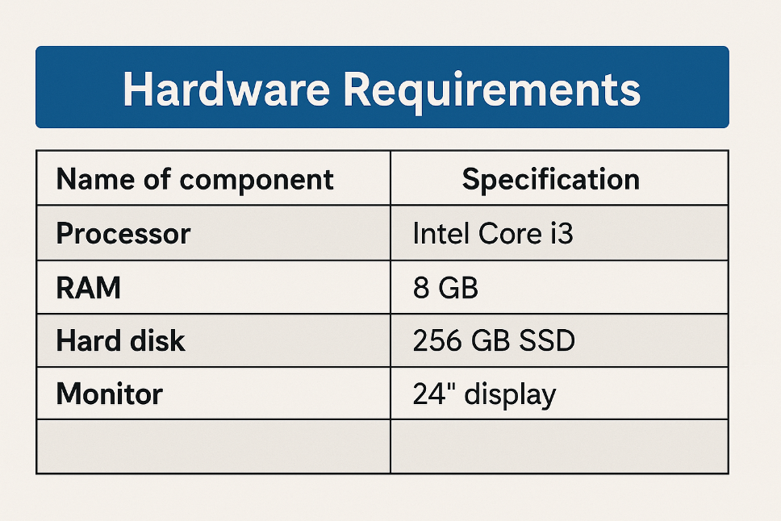

Chapter-5

5.1 Conclusion of the Project – Object Detection System
Our project, Object Detection System, is a comprehensive approach to automating the process of identifying and classifying objects in images or videos using advanced computer vision and deep learning techniques. The system is designed to detect multiple objects simultaneously, draw bounding boxes around them, and label them with high accuracy and confidence scores.
The primary objective of this project is to minimize human intervention in object identification tasks, enabling faster, more reliable, and real-time analysis in domains such as surveillance, traffic monitoring, industrial automation, and smart systems.
The system integrates image preprocessing, deep learning-based model inference (YOLO, SSD, or Faster R-CNN), and visual output generation, offering users an efficient, modular, and user-friendly platform for object recognition.

Key achievements of the project include:
- A detailed study and analysis of existing object detection models and their performance metrics.
- Definition of project objectives, scope, and real-world applications.
- Documentation of both functional and non-functional requirements.
- Development of modular architecture for efficient data handling, preprocessing, and inference.
- Implementation of real-time object detection using pre-trained deep learning models.
- Successful visualization of detection results with bounding boxes, class labels, and confidence scores.
- Integration of video processing for real-time detection from camera feeds.
- Comprehensive testing of the system using various datasets and real-world images to ensure accuracy and robustness.
The Object Detection System demonstrates the potential of AI and deep learning to automate visual analysis, significantly improving efficiency, accuracy, and reliability in multiple industries. It provides a strong foundation for advanced research and development in intelligent vision systems.

5.2 Future Scope of the Project – Object Detection System
The Object Detection System holds immense potential for enhancement through the integration of advanced AI features, optimized algorithms, and improved user interactivity. The following improvements can be considered for future development:
- Integration of Deep Learning Enhancements:
Adoption of state-of-the-art architectures like YOLOv8, EfficientDet, or DETR for higher accuracy and faster inference.
- Edge and IoT Deployment:
Optimization of the model for edge devices (e.g., Raspberry Pi, NVIDIA Jetson) to support real-time detection in low-power environments.
- Multi-Class Tracking:
Incorporation of object tracking algorithms (e.g., SORT, DeepSORT) for tracking detected objects across video frames.
- Custom Dataset Training:
Addition of tools to train models on custom datasets, enabling domain-specific applications such as medical imaging or manufacturing.
- Integration with Cloud Platforms:
Implementation of cloud services (Google Cloud, AWS, Azure) for scalable storage, processing, and live monitoring.
- AI Analytics Dashboard:
Development of an analytics interface showing detection statistics, accuracy trends, and false-positive analysis for performance evaluation.
- 3D Object Detection and Segmentation:
Future versions can incorporate 3D vision and instance segmentation for applications like autonomous vehicles or robotics.
- Enhanced Security and Privacy:
Ensuring that image/video data processing is secure and compliant with privacy standards for surveillance applications.
- Cross-Platform Compatibility:
Enabling deployment across desktop, web, and mobile platforms for wider accessibility and usability.
- Real-Time Alert and Automation System:
Integrating detection with alarm or alert systems for safety, traffic management, or intrusion detection.

Chapter-6
6.1 Sample code
6.2 Codes & Snapshots
6.2.1: formflask.py

6.2.2: formflask.py after running

6.2.3. LinkedIn Ui Interface :

6.2.4. Login Interface

6.2.5. Entering User E-mail:

6.2.6 LinkedIn Resume Builder Interface
      - Personal Details Pannel:

(2)Education Details Pannel:

(3)Projects Pannel:

(4) Skills Pannel:

(5) Hobbies Pannel:

(6)Output PDF:

6.3 References and Bibliography
- W3Schools. HTML, CSS, and JavaScript Tutorials.
Retrieved from https://www.w3schools.com
- Kaushik Shresth. How to Build a Python Desktop Assistant (YouTube Video).
Retrieved from https://www.youtube.com/@kaushikshresth
- Python Official Documentation. Built-in Modules and API Usage.
Retrieved from https://docs.python.org
- Groq Developer Documentation. Using Groq API for LLM Integration.
Retrieved from https://console.groq.com/docs
- Google Search Python Library. Using googlesearch module for web scraping.
Retrieved from https://pypi.org/project/googlesearch-python/
- Hugging Face API Documentation. Transformers and Inference API Usage.
Retrieved from https://huggingface.co/docs
- Cohere API Documentation. Natural Language Processing API Guide.
Retrieved from https://docs.cohere.com

6.4 Notes
The Object Detection System is built using Python, with libraries like TensorFlow, Keras, and OpenCV for detecting and classifying objects in images or videos. It uses pre-trained models such as YOLO, SSD, or Faster R-CNN for accurate, real-time detection.
The system captures input through a webcam or uploaded files, processes frames, and visualizes results with bounding boxes and labels. Configuration settings and model paths are securely managed using a .env file.
Detection results can be saved for analysis, and the system supports GPU acceleration for faster inference. It can be upgraded with a GUI, cloud integration, and database storage for enhanced performance and usability.

